IMT-2020: Evaluation of user-plane latency

Document for discussion and acceptance

Canadian Evaluation Group
2nd April 2019

Abbreviations

3GPP: 3rd Generation Partnership Project
BS: Base-station
BW: Bandwidth
CCE: Control channel element
CP: Control-plane
CSI-RS: Channel state information reference signal
DL: Downlink
DM-RS: Demodulation reference signal
gNB: g-NodeB
GoS: Grade-of-service
HARQ: Hybrid automatic repeat request
ITU: International Telecommunication Union
mMTC: massive Machine-Type Communications
NR: New Radio
NB-IoT: Narrowband-Internet of Things
PDCCH: Physical downlink control channel, PDSCH: Physical downlink shared channel
PRB: Physical resource block
PT-RS: Phase tracking reference signal
PUCCH: Physical uplink control channel; PUSCH: Physical uplink shared channel
QoS: Quality-of-service
RAN: Radio access network
RE: Resource element
RIT: Radio-interface technology
SCS: Sub-carrier spacing
SDU: Service data unit
SR: Scheduling request
SRS: Sounding reference symbol
SSB: Synchronization signal block
SCM: Stochastic channel model
TRxP: Transmission and reception point
TRS: Tracking reference signal
TTI: Transmission time interval
UE: User equipment
UL: Uplink
UP: User-plane

Introduction

In this paper, Ericsson presents the results of its evaluation of the user-plane (UP) latency in NR with different configurations and shows that the targets, which are 1 ms for URLLC and 4 ms for eMBB (see [1]), can be reached in both FDD and TDD. In the ITU target for reliability, there is also a requirement on latency (1 ms) during which the packet should be delivered with a certain probability. For this case, it is useful to evaluate how many retransmissions can be done within the latency limit.

Discussion
The following sub-sections analyse the worst-case UP latency after a first transmission and up to 3 re-transmissions. The ITU definition [1] of UP latency is “the one-way time taken to successfully deliver an application layer packet/message from the radio protocol layer 2/3 SDU ingress point to the radio protocol layer 2/3 SDU egress point of the radio interface in either uplink or downlink.”

Assumptions
Processing delay
This is the delay caused at the transmitter by preparation of the transmission and at the receiver by reception procedures and decoding.
On the DL, the processing delay in the UE includes the reception and decoding procedure. On the UL, there is also processing delay in the UE due to reception and decoding of the uplink grant. In gNB there is also processing delay as in the UE, with the addition that processing delay in the gNB also comprises delay caused by scheduling.
Alignment delay
The alignment delay is the time required after being ready to transmit until transmission actually starts. The assumption is the worst-case latency meaning the alignment delay is assumed to be the longest possible. PDCCH and PUCCH opportunities are assumed to be every scheduled TTI.
gNB timing
The minimum response time in the gNB between SR and UL grant, and between DL HARQ and re-transmission, is assumed to be 1 TTI. For higher SCS and fewer symbols in the mini-slot, the TTI is shorter, and more TTIs should be used for processing. The processing in gNB consists of three main components:
• Reception processing (PUSCH processing, SR/HARQ-ACK processing)
• Scheduling processing (including SDU/PDU processing for DL)
• L1 preparation processing for PDSCH and PDCCH
For simplicity the gNB processing time is referred to as the total processing time and further this processing time is equal for the cases that can occur. For example, the same processing time is assumed for scheduling first transmission and re-transmission. Same processing time is also assumed for DL and UL. The processing time is a lower limit for gNB response time, where the assumptions on gNB processing time are given in Table 1.
UE timing
The minimum response timing in the UE between DL data and DL HARQ, and between UL grant and UL data. On the DL, the UE processing time is according to N₁ value (Table 2), while on the UL, the UE processing time is according to N₂ value (Table 3) for UE capability #2.
UL scheduling
For UL data, the scheduling can either be based on SR or SPS UL. The assumption is that SR periodicity is 2os corresponding to the shortest periodicity allowed.

Timing | 15/30kHz SCS |  |  | 120kHz SCS
#Symbols | 7os TTI | 4os TTI | 2os TTI | 7os TTI | 4os TTI | 2os TTI
gNB processing | 7 | 4 | 4 | 14 | 12 | 10
Table 1: Processing time (in # of OFDM symbols) assumptions for gNB.

#Symbols | $$N_{1}$$
 | 15kHz SCS | 30kHz SCS | 120kHz SCS
Capability 2 | 3 | 4.5 | 20
Table 2: PDSCH processing time in OFDM symbols for the UE capabilities with front-loaded DM-RS.

#Symbols | $$N_{2}$$
 | 15kHz SCS | 30kHz SCS | 120kHz SCS
Capability 2 | 5 | 5.5 | 36
Table 3: PUSCH preparation procedure time.

TTI length and pattern

In this evaluation, Ericsson studied slot lengths of 14 symbols as well as mini-slots of 7, 4, and 2 symbols. For TDD, an alternating DL-UL pattern has been assumed, to represent the most latency-optimized setup in a carrier. With TDD, slot/mini-slots of 14, 7, and 4 symbols are studied.

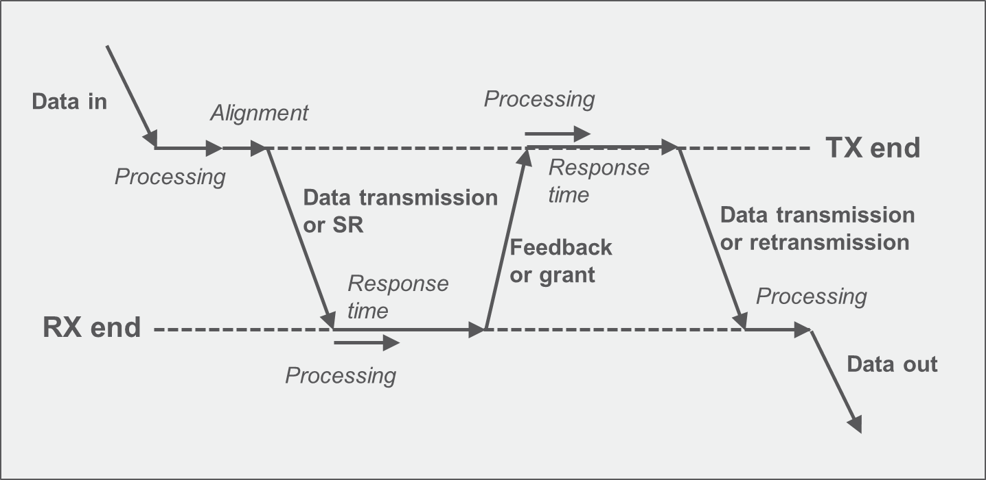
Figure 1: Illustration of latency components for DL and UL data.

FDD

For the case of FDD, the HARQ RTT is n+k TTI according to Table 1. The resulting UP latency for SCS of 15, 30 and 120 kHz is shown in Table 4. As can be seen, the 1ms requirement can be reached for SCS 15kHz and up depending on mini-slot configuration. On the UL, “configured” grants reduce the latency considerably compared to SR-based scheduling.

Latency (ms) | HARQ | 15kHz SCS |  |  |  | 30kHz SCS |  |  |  | 120kHz SCS
Latency (ms) | HARQ | 14-os TTI | 7-os TTI | 4-os TTI | 2-os TTI | 14-os TTI | 7-os TTI | 4-os TTI | 2-os TTI | 14-os TTI | 7-os TTI | 4-os TTI | 2-os TTI
DL data | 1st transmission | 3.2 | 1.7 | 1.3 | 0.86 | 1.7 | 0.91 | 0.7 | 0.48 | 0.55 | 0.43 | 0.38 | 0.31
DL data | 1 retx | 6.2 | 3.2 | 2.6 | 1.7 | 3.1 | 1.6 | 1.3 | 0.96 | 1.1 | 0.87 | 0.76 | 0.63
DL data | 2 retx | 9.2 | 4.7 | 3.6 | 2.6 | 4.7 | 2.4 | 2 | 1.5 | 1.6 | 1.3 | 1.1 | 0.96
DL data | 3 retx | 12 | 6.2 | 4.6 | 3.4 | 6.1 | 3.1 | 2.7 | 2 | 2.1 | 1.7 | 1.5 | 1.3
UL data (SR) | 1st transmission | 5.5 | 3 | 2.5 | 1.8 | 2.8 | 1.5 | 1.3 | 0.93 | 1.2 | 1.1 | 1 | 0.89
UL data (SR) | 1 retx | 9.4 | 4.9 | 3.9 | 2.6 | 4.7 | 2.4 | 2 | 1.4 | 1.9 | 1.7 | 1.6 | 1.3
UL data (SR) | 2 retx | 12 | 6.4 | 4.9 | 3.5 | 6.2 | 3.2 | 2.6 | 1.9 | 2.6 | 2.3 | 2.1 | 1.8
UL data (SR) | 3 retx | 15 | 7.9 | 5.9 | 4.4 | 7.7 | 3.9 | 3.3 | 2.3 | 3.2 | 2.8 | 2.6 | 2.2
UL data (CG) | 1st transmission | 3.4 | 1.9 | 1.4 | 0.93 | 1.7 | 0.95 | 0.7 | 0.48 | 0.7 | 0.57 | 0.52 | 0.45
UL data (CG) | 1 retx | 6.4 | 3.4 | 2.6 | 1.8 | 3.2 | 1.7 | 1.4 | 0.93 | 1.3 | 1.1 | 1.1 | 0.89
UL data (CG) | 2 retx | 9.4 | 4.9 | 3.9 | 2.6 | 4.7 | 2.4 | 2 | 1.4 | 1.9 | 1.7 | 1.6 | 1.3
UL data (CG) | 3 retx | 12 | 6.4 | 4.9 | 3.5 | 6.2 | 3.2 | 2.6 | 1.9 | 2.6 | 2.3 | 2.1 | 1.8
Table 4: FDD UP one-way latency for data transmission with HARQ-based retransmission, compared to the 1ms (green) and 4ms (orange) requirements.

- NR FDD can fulfill the 4 ms UP latency target with 15kHz SCS.
- NR FDD can fulfill the 1 ms UP latency target with 15kHz SCS, mini-slots, and UL configured grants.

TDD

With TDD, there are additional alignment delays caused by the sequence of DL and UL slots. Depending on when the data arrives in the transmit buffer, the latency may be the same or higher than the FDD latency. For a DL-UL pattern with HARQ RTT of n+4 TTI and higher (again following Table 1), the resulting latency is as indicated in Table 5. As can be seen in the table, the 4ms target can be reached with a SCS of 15kHz for 7-symbol mini slot, while 30 kHz SCS is possible also with slot length transmission. The 1ms target can be reached with 120kHz SCS and mini-slots for DL and UL configured grant transmissions.

Latency (ms) | HARQ | 15kHz SCS |  |  | 30kHz SCS |  |  | 120kHz SCS
Latency (ms) | HARQ | 14-os TTI | 7-os TTI | 4-os TTI | 14-os TTI | 7-os TTI | 4-os TTI | 14-os TTI | 7-os TTI | 4-os TTI
DL data | 1st transmission | 4.2 | 2.7 | 2.3 | 2.2 | 1.4 | 1.2 | 0.68 | 0.55 | 0.51
DL data | 1 retx | 8.2 | 4.7 | 4.3 | 4.1 | 2.4 | 2.2 | 1.4 | 1.1 | 1
DL data | 2 retx | 12 | 6.7 | 6.3 | 6.2 | 3.4 | 3.2 | 2.2 | 1.6 | 1.5
DL data | 3 retx | 16 | 8.7 | 8.3 | 8.1 | 4.4 | 4.2 | 2.9 | 2.1 | 2
UL data (SR) | 1st transmission | 7.5 | 4.5 | 4.1 | 3.8 | 2.3 | 2.1 | 1.5 | 1.2 | 1.2
UL data (SR) | 1 retx | 12 | 6.9 | 6.4 | 6.2 | 3.4 | 3.2 | 2.3 | 1.9 | 1.7
UL data (SR) | 2 retx | 16 | 8.9 | 8.4 | 8.2 | 4.5 | 4.2 | 3.1 | 2.5 | 2.2
UL data (SR) | 3 retx | 20 | 11 | 10 | 10 | 5.4 | 5.2 | 3.8 | 3.2 | 2.7
UL data (CG) | 1st transmission | 4.4 | 2.9 | 2.4 | 2.2 | 1.4 | 1.2 | 0.82 | 0.7 | 0.64
UL data (CG) | 1 retx | 8.4 | 4.9 | 4.4 | 4.2 | 2.5 | 2.2 | 1.6 | 1.3 | 1.2
UL data (CG) | 2 retx | 12 | 6.9 | 6.4 | 6.2 | 3.4 | 3.2 | 2.3 | 1.9 | 1.7
UL data (CG) | 3 retx | 16 | 8.9 | 8.4 | 8.2 | 4.5 | 4.2 | 3.1 | 2.5 | 2.2
Table 5: TDD UP one-way latency for data transmission with alternating DL-UL slot pattern, compared to the 1ms (green) and 4ms (orange) requirements.

Conclusion

In section 3.2, the following observations were made:

- NR FDD can fulfill the 4ms UP latency target with 15kHz SCS.
- NR FDD can fulfill the 1ms UP latency target with 15kHz SCS, mini-slots, and UL configured grants.
- NR TDD can fulfil the 4ms UP latency target with 15 kHz SCS, mini-slot and configured UL grants.
- NR TDD can fulfil the 1ms UP latency target with 120 kHz SCS, mini-slots and configured UL grants.
From the above, it is concluded that:

- NR fulfills the IMT-2020 requirements on latency.

References

- ITU-R Report M.2410, “Minimum requirements related to technical performance for IMT-2020 radio interface(s)”
- ITU-R Report M.2412, “Guidelines for evaluation of radio interface technologies for IMT-2020”

In NR Rel. 15 no value (lower than for Capability 1) for 120 kHz SCS was agreed.
In NR Rel. 15 no value (lower than for Capability 1) for 120 kHz SCS was agreed.

