Table 1: Comparing Spectral Efficiency Results for Dense Urban eMBB Configurations
Channel model A | RIT | Antenna and TXRU mapping | Antenna config & Tx scheme | Req. |  | Huawei | Samsung | Univ of Toronto
DL Spectral efficiency | FDD
DL Spectral efficiency | NR | gNB: (M,N,P,Mg,Ng; Mp,Np) = (8,8,2,1,1;2,8) | 32x4 MU-MIMO Type II Codebook  (128Tx@gNB) | Average [bit/s/Hz/TRxP] | 7.8 | 11.450 | 10.650 | 11.27
 |  |  |  | 5th percentile [bit/s/Hz] | 0.225 | 0.376 | 0.308 | 0.38
DL Spectral efficiency | TDD
DL Spectral efficiency | NR | gNB: (M,N,P,Mg,Ng; Mp,Np) = (8,8,2,1,1;2,8) | 32x4 MU-MIMO, 4T SRS  (128Tx@gNB) | Average [bit/s/Hz/TRxP] | 7.8 | 12.951 | - | 13.371
 |  |  |  | 5th percentile [bit/s/Hz] | 0.225 | 0.388 | - | 0.43
UL Spectral efficiency | FDD
UL Spectral efficiency | NR | gNB: (M,N,P,Mg,Ng; Mp,Np) = (8,8,2,1,1;1,8) | 2x16 SU-MIMO, OFDMA | Average [bit/s/Hz/TRxP] | 5.4 | 6.772 | 6.451 | 6.512
 |  |  |  | 5th percentile [bit/s/Hz] | 0.15 | 0.254 | 0.206 | 0.228
UL Spectral efficiency | TDD
UL Spectral efficiency | NR | gNB: (M,N,P,Mg,Ng; Mp,Np) = (8,8,2,1,1;2,8) | 2x32 SU-MIMO, Codebook based, OFDMA | Average [bit/s/Hz/TRxP] | 5.4 | 6.570 | - | 6.462
 |  |  |  | 5th percentile [bit/s/Hz] | 0.15 | 0.278 | - | 0.213
Channel model B | RIT | Antenna and TXRU mapping | Antenna config & Tx scheme | Req. |  | Huawei | CATT | Univ of Toronto
DL Spectral efficiency | FDD
DL Spectral efficiency | NR | gNB: (M,N,P,Mg,Ng; Mp,Np) = (8,8,2,1,1;2,8) | 32x4 MU-MIMO Type II Codebook  (128Tx@gNB) | Average [bit/s/Hz/TRxP] | 7.8 | 11.417 | 12.530 | 11.36
 |  |  |  | 5th percentile [bit/s/Hz] | 0.225 | 0.379 | 0.448 | 0.35
DL Spectral efficiency | TDD
DL Spectral efficiency | NR | gNB: (M,N,P,Mg,Ng; Mp,Np) = (8,8,2,1,1;2,8) | 32x4 MU-MIMO, 4T SRS  (128Tx@gNB) | Average [bit/s/Hz/TRxP] | 7.8 | 12.818 | - | 13.144
 |  |  |  | 5th percentile [bit/s/Hz] | 0.225 | 0.392 | - | 0.37
UL Spectral efficiency | FDD
UL Spectral efficiency | NR | gNB: (M,N,P,Mg,Ng; Mp,Np) = (8,8,2,1,1;1,8) | 2x16 SU-MIMO, OFDMA | Average [bit/s/Hz/TRxP] | 5.4 | 6.669 | - | 6.397
 |  |  |  | 5th percentile [bit/s/Hz] | 0.15 | 0.219 | - | 0.264
UL Spectral efficiency | TDD
UL Spectral efficiency | NR | gNB: (M,N,P,Mg,Ng; Mp,Np) = (8,8,2,1,1;2,8) | 2x32 SU-MIMO, Codebook based, OFDMA | Average [bit/s/Hz/TRxP] | 5.4 | 8.080 | - | 7.752
 |  |  |  | 5th percentile [bit/s/Hz] | 0.15 | 0.323 | - | 0.291

Table 2: Comparing Spectral Efficiency Results for Rural eMBB Configurations at 700 MHz
Channel model A | RIT | Antenna and TXRU mapping | Antenna config & Tx scheme | Req. |  | Huawei | CATT | Univ of Toronto
DL Spectral efficiency | FDD
DL Spectral efficiency | NR | gNB: (M,N,P,Mg,Ng; Mp,Np) = (8,4,2,1,1;1,4) | 8x2 MU-MIMO Type II Codebook | Average [bit/s/Hz/TRxP] | 5.4 | 6.594 | 6.890 | 6.152
 |  |  |  | 5th percentile [bit/s/Hz] | 0.15 | 0.138 | 0.199 | 0.162
DL Spectral efficiency | TDD
DL Spectral efficiency | NR | gNB: (M,N,P,Mg,Ng; Mp,Np) = (8,8,2,1,1;2,8) | 32x4 MU-MIMO, 4T SRS  (128Tx@gNB) | Average [bit/s/Hz/TRxP] | 5.4 | 6.136 | - | 7.49
 |  |  |  | 5th percentile [bit/s/Hz] | 0.15 | 0.276 | - | 0.159
UL Spectral efficiency | FDD
UL Spectral efficiency | NR | gNB: (M,N,P,Mg,Ng; Mp,Np) = (8,8,2,1,1;1,8) | 2x16 SU-MIMO, OFDMA | Average [bit/s/Hz/TRxP] | 5.4 | 6.772 | - | 6.951
 |  |  |  | 5th percentile [bit/s/Hz] | 0.15 | 0.254 | - | 0.248
UL Spectral efficiency | TDD
UL Spectral efficiency | NR | gNB: (M,N,P,Mg,Ng; Mp,Np) = (8,8,2,1,1;2,8) | 2x32 SU-MIMO, Codebook based, OFDMA | Average [bit/s/Hz/TRxP] | 5.4 | 6.136 | - | 5.872
 |  |  |  | 5th percentile [bit/s/Hz] | 0.15 | 0.276 | - | 0.193
Channel model B | RIT | Antenna and TXRU mapping | Antenna config & Tx scheme | Req. |  | Huawei | CATT | Univ of Toronto
DL Spectral efficiency | FDD
DL Spectral efficiency | NR | gNB: (M,N,P,Mg,Ng; Mp,Np) = (8,8,2,1,1;2,8) | 32x4 MU-MIMO Type II Codebook  (128Tx@gNB) | Average [bit/s/Hz/TRxP] | 3.3 | 6.537 | 7.060 | 6.48
 |  |  |  | 5th percentile [bit/s/Hz] | 0.12 | 0.130 | 0.189 | 0.187
DL Spectral efficiency | TDD
DL Spectral efficiency | NR | gNB: (M,N,P,Mg,Ng; Mp,Np) = (8,8,2,1,1;2,8) | 32x4 MU-MIMO, 4T SRS  (128Tx@gNB) | Average [bit/s/Hz/TRxP] | 3.3 | 12.818 | - | 13.144
 |  |  |  | 5th percentile [bit/s/Hz] | 0.12 | 0.392 | - | 0.37
UL Spectral efficiency | FDD
UL Spectral efficiency | NR | gNB: (M,N,P,Mg,Ng; Mp,Np) = (8,4,2,1,1;1,4) | 8x2 MU-MIMO, 2T SRS | Average [bit/s/Hz/TRxP] | 3.3 | 7.573 | - | 7.125
 |  |  |  | 5th percentile [bit/s/Hz] | 0.12 | 0.159 | - | 0.189
UL Spectral efficiency | TDD
UL Spectral efficiency | NR | gNB: (M,N,P,Mg,Ng; Mp,Np) = (8,4,2,1,1;1,4) | 1x8 SU-MIMO, OFDMA | Average [bit/s/Hz/TRxP] | 1.6 | 4.294 | - | 3.361
 |  |  |  | 5th percentile [bit/s/Hz] | 0.045 | 0.128 | - | 0.132

Table 3: Comparing Mobility Results for Dense Urban eMBB Configurations
Channel model A  4 GHz | RIT | Antenna config & Tx scheme | Req. |  | Numerology | Channel cond. | Huawei | CATT | Univ of Toronto
UL Mobility | FDD
UL Mobility | NR | 1x8 SU-MIMO, OFDMA | Normalized traffic channel link data rate (bit/s/Hz) | 1.12 | 15 kHz SCS | NLOS | 1.92 | 2.09 | 2.03
 |  |  |  |  |  | LOS | 2.22 | 2.40 | 2.29
UL Mobility | TDD
UL Mobility | NR | 1x8 SU-MIMO, OFDMA | Normalized traffic channel link data rate (bit/s/Hz) | 1.12 | 30 kHz SCS | NLOS | 1.82 | - | 1.76
 |  |  |  |  |  | LOS | 2.17 | - | 1.95
Channel model B  4GHz | RIT | Antenna config & Tx scheme | Req. |  | Numerology | Channel cond. | Huawei | CATT | Univ of Toronto
UL Mobility | FDD
UL Mobility | NR | 1x8 SU-MIMO, OFDMA | Normalized traffic channel link data rate (bit/s/Hz) | 1.12 | 15 kHz SCS | NLOS | 1.89 | 2.06 | 1.95
 |  |  |  |  |  | LOS | 2.19 | 2.35 | 2.21
UL Mobility | TDD
UL Mobility | NR | 1x8 SU-MIMO, OFDMA | Normalized traffic channel link data rate (bit/s/Hz) | 1.12 | 30 kHz SCS | NLOS | 1.79 | - | 1.62
 |  |  |  |  |  | LOS | 2.06 | - | 1.83
Channel model A/B 30GHz | RIT | Antenna config & Tx scheme | Req. |  | Numerology | Channel cond. | Huawei | NTT DOCOMO | Univ of Toronto
UL Mobility | FDD
UL Mobility | NR | 1x4 SIMO | Normalized traffic channel link data rate (bit/s/Hz) | 1.12 | 60kHz | NLOS | - | 1.24 | 1.18
 |  |  |  |  |  | LOS | - | - | -

Table 4: Comparing Mobility Results for Rural eMBB Configurations
Channel model A  120km/h | RIT | Antenna config & Tx scheme | Req. |  | Numerology | Channel cond. | Huawei | Univ of Toronto
FDD
UL Mobility | NR | 1x4 SIMO,  OFDMA | Normalized traffic channel link data rate (bit/s/Hz) | 0.8 | 15 kHz SCS | NLOS | 2.32 | 2.13
 |  |  |  |  |  | LOS | 2.90 | 2.57
UL Mobility | TDD
UL Mobility | NR | 1x4 SIMO,  SC-FDMA | Normalized traffic channel link data rate (bit/s/Hz) | 0.8 | 15 kHz SCS | NLOS | 2.10 | 1.92
 |  |  |  |  |  | LOS | 2.63 | 2.18
Channel model A  500km/h | RIT | Antenna config & Tx scheme | Req. |  | Numerology | Channel cond. | Huawei | Univ of Toronto
FDD
UL Mobility | NR | 1x4 SIMO,  OFDMA | Normalized traffic channel link data rate (bit/s/Hz) | 0.45 | 15 kHz SCS | NLOS | 2.07 | 1.95
 |  |  |  |  |  | LOS | 2.64 | 2.21
UL Mobility | TDD
UL Mobility | NR | 1x4 SIMO,  OFDMA | Normalized traffic channel link data rate (bit/s/Hz) | 0.45 | 30 kHz SCS | NLOS | 1.88 | 1.62
 |  |  |  |  |  | LOS | 2.39 | 1.83
Channel model B  120km/h | RIT | Antenna config & Tx scheme | Req. |  | Numerology | Channel cond. | Huawei | Univ of Toronto
FDD
UL Mobility | NR | 1x4 SIMO,  OFDMA | Normalized traffic channel link data rate (bit/s/Hz) | 0.8 | 15 kHz SCS | NLOS | 2.31 | 2.15
 |  |  |  |  |  | LOS | 2.90 | 2.62
UL Mobility | TDD
UL Mobility | NR | 1x4 SIMO,  SC-FDMA | Normalized traffic channel link data rate (bit/s/Hz) | 0.8 | 15 kHz SCS | NLOS | 2.09 | 1.94
 |  |  |  |  |  | LOS | 2.63 | 2.14
Channel model B  500km/h | RIT | Antenna config & Tx scheme | Req. |  | Numerology | Channel cond. | Huawei | Univ of Toronto
FDD
UL Mobility | NR | 1x4 SIMO,  OFDMA | Normalized traffic channel link data rate (bit/s/Hz) | 0.45 | 15 kHz SCS | NLOS | 2.07 | 1.92
 |  |  |  |  |  | LOS | 2.64 | 2.27
UL Mobility | TDD
UL Mobility | NR | 1x4 SIMO,  OFDMA | Normalized traffic channel link data rate (bit/s/Hz) | 0.45 | 30 kHz SCS | NLOS | 1.87 | 1.67
 |  |  |  |  |  | LOS | 2.39 | 1.88

Table 5: Comparing Connection Density Results for mMTC Configurations

Channel model A | RIT | Antenna config & Tx scheme | Req. |  | Numerology | Huawei | Ericsson | Univ of Toronto
FDD
Connection Density | NB-IoT | 1x2 SIMO, Single-tone (16 Rx@BS) | Connection density (/km2) | 1000000 | 15 kHz SCS | 2,517,000 | 2,237,326 | 2,314,259
Connection Density | NB-IoT | 1x2 SIMO, Single-tone (16 Rx@BS) | Bandwidth (kHz) |  |  | 180 | 180 | 180
Connection Density | eMTC | 1x2 SIMO, DFT-S-OFDM (16 Rx@BS) | Connection density (/km2) | 1000000 | 15 kHz SCS | 1,344,000 | 1,231,947 | 1,214,735
Connection Density | eMTC | 1x2 SIMO, DFT-S-OFDM (16 Rx@BS) | Bandwidth (kHz) |  |  | 180 | 180 | 180
Connection Density | NR | 1x2 SIMO, OFDMA (16 Rx@BS) | Connection density (/km2) | 1000000 | 15 kHz SCS | 1,138,000 | 1,269,767 | 1,267,312
Connection Density | NR | 1x2 SIMO, OFDMA (16 Rx@BS) | Bandwidth (kHz) |  |  | 180 | 180 | 180
Channel model B | RIT | Antenna config & Tx scheme | Req. |  | Numerology | Huawei | Ericsson | Univ of Toronto
FDD
Connection Density | NB-IoT | 1x2 SIMO, Single-tone (16 Rx@BS) | Connection density (/km2) | 1000000 | 15 kHz SCS | 2,650,000 | 2,103,872 | 2,372,839
Connection Density | NB-IoT | 1x2 SIMO, Single-tone (16 Rx@BS) | Bandwidth (kHz) |  |  | 180 | 180 | 180
Connection Density | eMTC | 1x2 SIMO, DFT-S-OFDM (16 Rx@BS) | Connection density (/km2) | 1000000 | 15 kHz SCS | 1,699,000 | 1,476,635 | 1,416,973
Connection Density | eMTC | 1x2 SIMO, DFT-S-OFDM (16 Rx@BS) | Bandwidth (kHz) |  |  | 180 | 180 | 180
Connection Density | NR | 1x2 SIMO, OFDMA (16 Rx@BS) | Connection density (/km2) | 1000000 | 15 kHz SCS | 1,465,000 | 1,575,368 | 1,518,832
Connection Density | NR | 1x2 SIMO, OFDMA (16 Rx@BS) | Bandwidth (kHz) |  |  | 180 | 180 | 180

Table 6: Reliability for 700 MHz, Model A
Channel Model A Downlink Reliability | Antenna Configuration | URLLC Requirement | Huawei | CATT | Nokia | Intel | Univ of Toronto
Channel Model A Downlink Reliability | 2x2 SU-MIMO 14os one-shot (1 PDCCH+1 PDSCH) | 99.999% | 99.9998% |  |  |  | 99.99969%
Channel Model A Downlink Reliability | 2x2 SU-MIMO 7os one-shot (1 PDCCH+1 PDSCH) | 99.999% | 99.9998% | 99.99904% |  | > 99.9999% | 99.9997%
Channel Model A Downlink Reliability | 2x2 SU-MIMO 4os slot aggregation = 2 (1 PDCCH + 2 PDSCH) | 99.999% | 99.9995% |  |  |  | 99.999263%
Channel Model A Downlink Reliability | 16x4 SU-MIMO 14os (1PDCCH + 1 PDSCH) | 99.999% |  |  | 99.999%
Channel Model A Uplink Reliability | 1x8 SIMO, OFDMA, 14os one-shot (1 PUSCH) | 99.999% | 99.9999% |  |  |  | 99.9999%
Channel Model A Uplink Reliability | 1x2 SIMO, OFDMA, 7os one-shot (2 PUSCH) | 99.999% |  |  | 9.9992%
Channel Model A Uplink Reliability | 1x8 SIMO 7os (1 PUSCH) | 99.999% |  |  |  | > 99.9999%
Channel Model A Uplink Reliability | 1x8 SIMO, OFDMA, 14os one-shot (1 PUSCH, 8RB) | 99.999% |  | 99.9993%

Table 7: Reliability for 700 MHz, Model B
Channel Model B Downlink Reliability | Antenna Configuration | URLLC Requirement | Huawei | CATT | Intel | Univ of Toronto
Channel Model B Downlink Reliability | 2x2 SU-MIMO 14os one-shot (1 PDCCH+1 PDSCH) | 99.999% | 99.9998% | 99.99904400% |  | 99.99969%
Channel Model B Downlink Reliability | 2x2 SU-MIMO 7os one-shot (1 PDCCH+1 PDSCH) | 99.999% | 99.999% | 99.9991% | > 99.9999% | 99.9998%
Channel Model B Downlink Reliability | 2x2 SU-MIMO 4os slot aggregation = 2 (1 PDCCH + 2 PDSCH) | 99.999% | 99.9995%
Channel Model B Uplink Reliability | 1x8 SIMO, OFDMA, 14os one-shot (1 PUSCH) | 99.999% | 99.9999% |  |  | 99.9999941%
Channel Model B Uplink Reliability | 1x2 SIMO, OFDMA, 7os one-shot (2 PUSCH) | 99.999%
Channel Model B Uplink Reliability | 1x8 SIMO 7os (1 PUSCH) | 99.999% |  |  | > 99.9999%
Channel Model B Uplink Reliability | 1x8 SIMO, OFDMA, 14os one-shot (1 PUSCH, 8RB) | 99.999% |  | 99.999%

Table 8: Reliability for 4 GHz, Model A
Channel Model A Downlink Reliability | Antenna Configuration | URLLC Requirement | Huawei | Nokia | Intel | Univ of Toronto
Channel Model A Downlink Reliability | 2x2 SU-MIMO 14os slot aggregation = 2 (1 PDCCH + 2 PDSCH) | 99.999% | 99.9998% |  |  | 99.9999%
Channel Model A Downlink Reliability | 32x8 SU-MIMO 14os (1PDCCH + 1 PDSCH) | 99.999% |  | 99.999%
Channel Model A Downlink Reliability | 2x4 SU-MIMO 7os slot aggregation = 1 (1 PDCCH + 1 PDSCH) | 99.999% |  |  | > 99.9999%
Channel Model A Uplink Reliability | 1x16 SIMO, OFDMA , 14os, one-shot (1 PUSCH) | 99.999% | 99.9998% |  |  | 99.9997%
Channel Model A Uplink Reliability | 1x8 SIMO 7os (1 PUSCH) | 99.999% |  |  | > 99.9999%
Channel Model A Uplink Reliability | 1x2 SIMO 4os (2 PUSCH) | 99.999% |  | 99.999%

Table 9: Reliability for 4 GHz, Model B
Channel Model B Downlink Reliability | Antenna Configuration | URLLC Requirement | Huawei | Intel | Univ of Toronto
Channel Model B Downlink Reliability | 2x2 SU-MIMO 14os slot aggregation = 2 (1 PDCCH + 2 PDSCH) | 99.999% | 99.99990561% |  | 99.99969%
Channel Model B Downlink Reliability | 32x8 SU-MIMO 14os (1PDCCH + 1 PDSCH) | 99.999%
Channel Model B Downlink Reliability | 2x4 SU-MIMO 7os slot aggregation = 1 (1 PDCCH + 1 PDSCH) | 99.999% |  | > 99.9999%
Channel Model B Downlink Reliability | 2x2 SU-MIMO 4os (2 PDCCH + 2 PDSCH) | 99.999%
Channel Model B Uplink Reliability | 1x16 SIMO, OFDMA, 14os, one-shot (1 PUSCH) | 99.999% | 99.9999% |  | 99.9999%
Channel Model B Uplink Reliability | 1x8 SIMO 14os (1 PUSCH, 12RB) | 99.999% |  | > 99.9999%

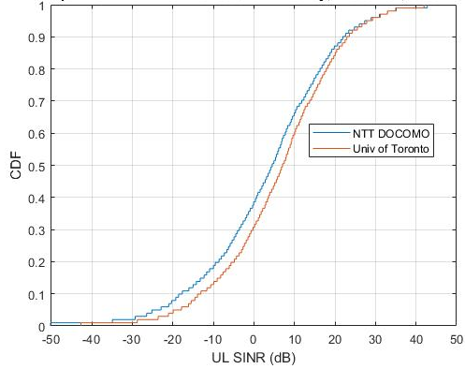
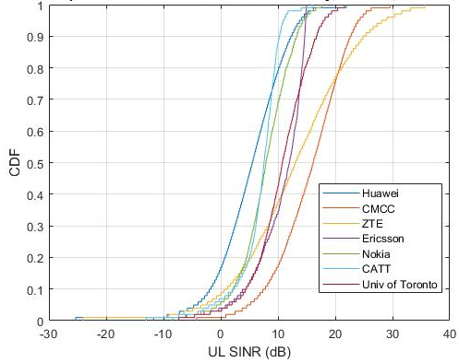
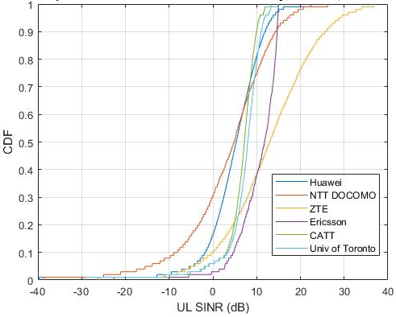
Figure 2: Uplink CDF of SINR for eMBB Dense Urban Mobility, f=30 GHz Models A/B
Figure 1: Uplink CDF of SINR for eMBB Dense Urban Mobility, f=4 GHz Model A (left) and Model B (right)

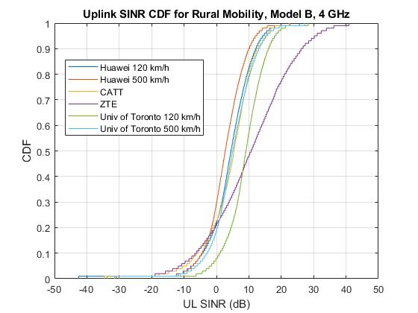
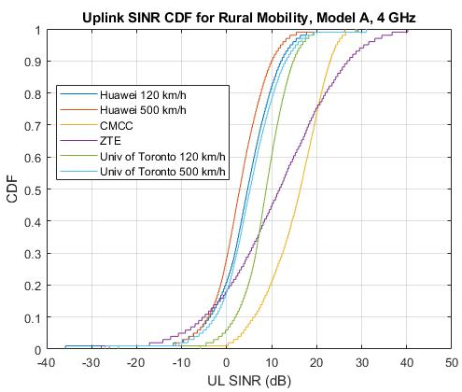
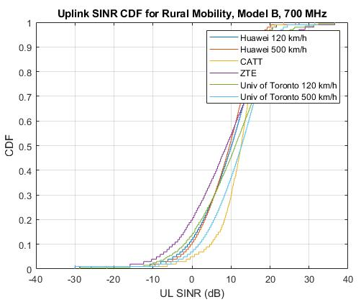
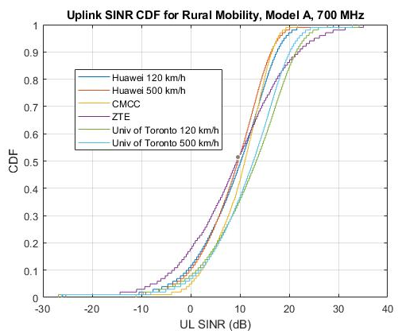
Figure 3: Uplink CDF of SINR for eMBB Rural Mobility

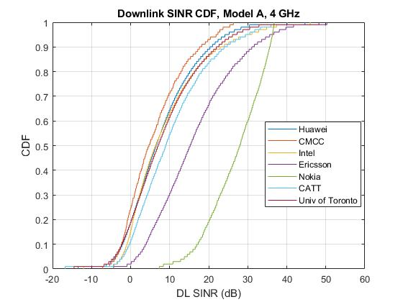
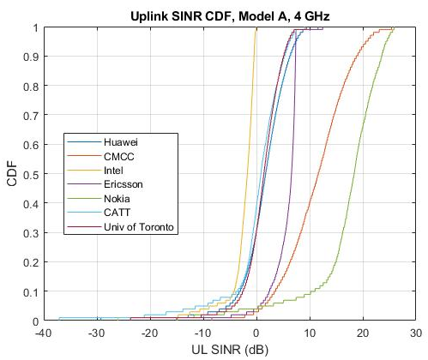
Figure 2: CDF of Downlink SINR for reliability using Model A with 4 GHz
Figure 3: CDF of Uplink SINR for reliability using Model A with 4 GHz
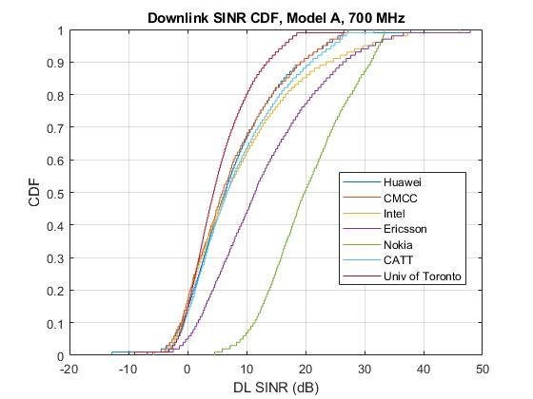
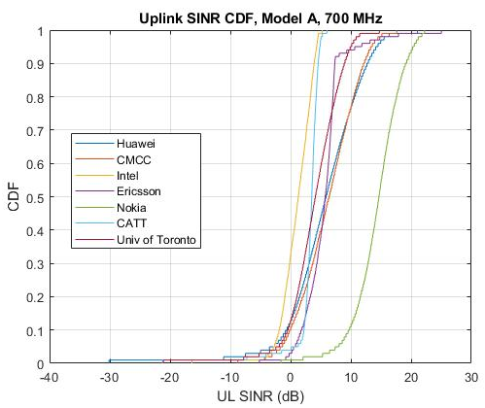
Figure 4: CDF of Downlink SINR for reliability using Model A with 700 MHz
Figure 5: CDF of Uplink SINR for reliability using Model A with 700 MHz
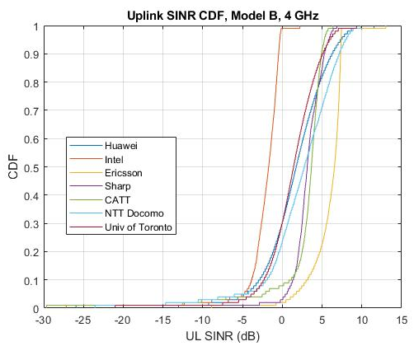
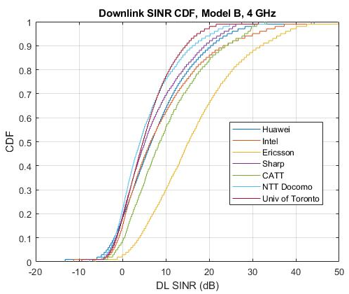
Figure 6: CDF of Uplink SINR for reliability using Model B with 4 GHz
Figure 7: CDF of Downlink SINR for reliability using Model B with 4 GHz
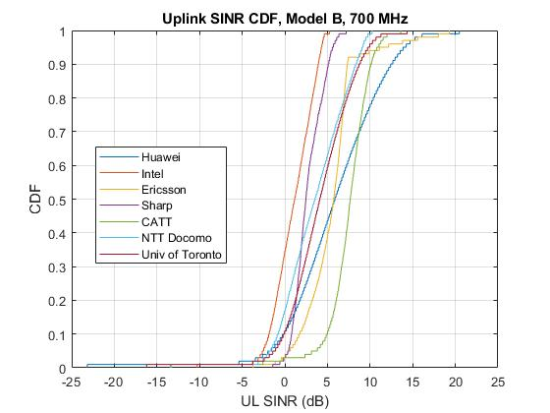
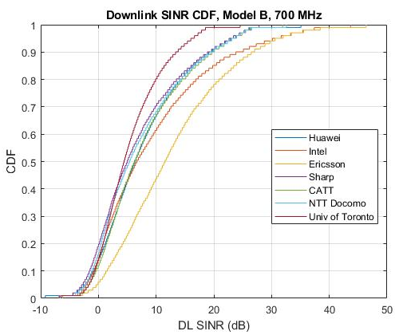
Figure 8: CDF of Uplink SINR for reliability using Model B with 700 MHz
Figure 9: CDF of Downlink SINR for reliability using Model B with 700 MHz

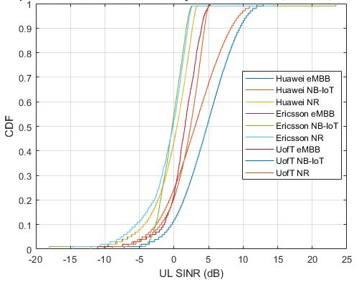
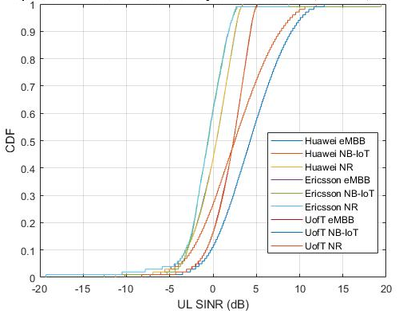
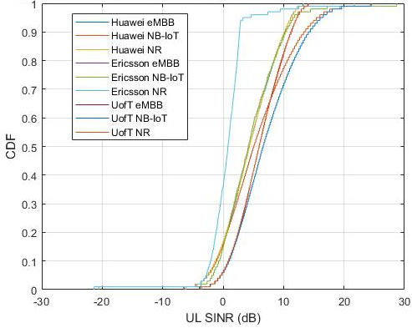
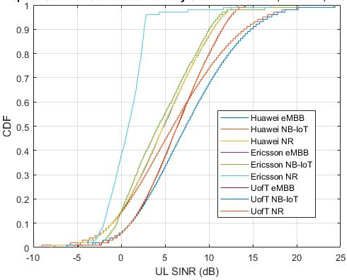
Figure 4: Uplink CDF of SINR for mMTC Connection Density with inter-site distance/Model: 1732m/A (top left), 1732m/B (top right), 500m/A (bottom left), 500m/B (bottom right)

