Radiocommunication Study Groups | 
Attachment 7.4 to Document 5D/360
(Source: Document 5D/TEMP/201(Rev.1))
 | 27 October 2020
 | English only
Working Party 5D
LIAISON STATEMENT TO INDEPENDENT EVALUATION GROUPS
(COPY TO “ETSI (TC DECT) AND DECT FORUM PROPONENT” AND “NUFRONT PROPONENT”)
Invitation to IEGs to re-engage in Step 4 evaluation of the “ETSI (TC DECT) and DECT Forum Proponent” and of the “Nufront Proponent” candidate technology submissions for IMT-2020 under the ‘Way Forward’ Option 2 exceptional basis IMT-2020 process extension
Working Party (WP) 5D thanks the registered Independent Evaluation Groups for their active participation in the IMT-2020 process. As noted in the prior liaison dispatched via email on 15 July 2020 from Mr Sergio Buonomo, WP 5D at that time had indicated that:
“WP 5D takes this opportunity to express appreciation to the work carried out by the Independent Evaluation Groups and would welcome further opportunity in the future to engage with the IEGs who have been active in the IMT-2020 process evaluations.”
Due to the previously unforeseen need to continue the evaluation of certain IMT-2020 candidate technology submissions, ITU-R is again seeking the engagement of the registered IEGs and their expertise.

I) Background
As noted in the referenced Addendum 7 to the Circular Letter 5/LCCE/59 that was indicated in the same liaison, it was announced that ITU-R had determined that the IMT-2020 candidate technology submission proposals for
– Candidate SRIT submission from ETSI (TC DECT) and DECT Forum (Acknowledgement of submission under Step 3 of the IMT-2020 process in IMT-2020/17(Rev.1)).
– Candidate RIT submission from Nufront (Acknowledgement of submission under Step 3 of the IMT-2020 process in IMT-2020/18(Rev.1)).
would require additional evaluation to conclude their respective final assessment through Steps 6 and 7 of the current process. Hence, they are not included in the draft new Recommendation ITU-R M.[IMT-2020.SPECS] – Detailed specifications of the terrestrial radio interfaces of International Mobile Telecommunications-2020 (IMT-2020) that will be provided to the 23-24 November 2020 meeting of Study Group 5.
These candidate technologies will, therefore, on a one-time exceptional basis, continue in the current IMT-2020 process (setting no future precedent), rewinding to the start of Step 4 in order to consider additional material (see Document IMT-2020/52). Should each of these technology submissions individually and separately successfully navigate through Step 4 and the subsequent Steps 5-8 of the current IMT-2020 process extension, they would consequentially be included in a timely focused revision to the published first release of Recommendation ITU-R M.[IMT-2020.SPECS].
A high-level timeline is provided in Annex 1 as an overview to the more detailed schedule available in other documents announced by this liaison.

II) Formal Invitation Extended to Independent Evaluation Groups on the ‘Way Forward’ Option 2 reset to Step 4
The purpose of this current liaison is to kindly invite the IEGs (i.e., only those specifically addressed on this liaison) previously engaged in the prior finalized Step 4 evaluation activities under the existing IMT-2020 process to re-engage in the renewed Step 4 evaluation, specifically for the two candidate technologies refenced above.
This invitation for further and/or updated evaluations is extended to the previous IEGs whether the Evaluation Group did or did not previously provide any evaluation reports on these two candidate technologies in the prior Step 4 evaluation period. An evaluation may be provided for either or both Option 2 candidate technologies.
A previously registered IEG at ITU-R is not required to register again to participate in this ‘Way Forward’ Option 2 as their prior registration remains valid.
However, as will be indicated below in this liaison, formal notification to the Bureau (Mr. Uwe Loewenstein) is requested and required should the IEG decide to participate in the Option 2 Step 4.

III) Further Details on the ‘Way Forward’ Option 2 reset to Step 4
For further information and details please consult
– Circular Letter 5/LCCE/89 Announcement of the detailed schedule for the process extension for two candidate technology submissions for IMT-2020 requiring additional evaluation in the current IMT-2020 process.
– Document IMT-2020/53 Detailed schedule and actions for ‘Way Forward’ Option 2 related to “ETSI (TC DECT) and DECT Forum Proponent” and “NUFRONT Proponent” Candidate Technology Submissions for IMT-2020 provides further information and timelines that should be considered by the IEGs.

IV) A Reply of the IEG intention to evaluate is kindly requested by 15 February 2021
Working Party 5D would appreciate receiving by no later than WP 5D virtual Meeting #37 (22 February to March 5 2021 – deadline for submissions 15 February 2021) the view of each Evaluation Group on this invitation to re-engage in either or both technology evaluations.
NOTE: WP 5D is also holding a virtual Meeting #36bis (17-19 November 2020 – deadline for submissions 10 November 2020) with a specific focus on Technology Aspects work for finalization of the draft new Recommendation ITU-R M.[IMT-2020.SPECS]. While the re-engagement to Step 4 and ‘Way Forward’ Option 2 is not a primary item of the agenda of Meeting #36bis, WP 5D would certainly welcome any early responses of the IEGs on the above invitation to this session of WP 5D, as this could further facilitate planning for 2021.

V) Evaluation is encouraged to start in advance of and prior to formally informing WP 5D at Meeting #37
It is anticipated that prior to WP 5D being formally notified by an IEG of their interest in performing evaluation under this reset to Step 4, that the Option 2 Proponents and Evaluation Groups would proceed with evaluation work in advance of any need to officially notify ITU-R/WP 5D. This is an encouraged action to maximize the time available for evaluation work given the only-three-meeting-cycle to complete the ‘Way Forward’ Option 2 and the extraordinary global working circumstances that may remain in response to the COVID-19 situation.
An informal email communique to the Counsellor of Study Group 5 with copy to the Chairman and Vice-Chairmen of WP 5D of such a head start prior to the formal notification would be appreciated in order to ensure the support of the BR for aspects such as the Evaluation Group discussion area and for practical coordination.

VI) Materials useful to the Option 2 evaluation reset to Step 4 and coordination of information
For materials considered relevant to the Option 2 evaluation under the reset to Step 4, please see Annex 2 for “ETSI (TC DECT) and DECT Forum Proponent” and Annex 3 for “Nufront Proponent” candidate technology submissions respectively.
WP 5D takes this opportunity to express appreciation to the work carried out by the Independent Evaluation Groups and would welcome further opportunity in the future to engage with the IEGs who have been active in the IMT-2020 process evaluations.
Evaluations should also continue to adhere to the relevant IMT-2020 process guidance documents found in:
– Resolution ITU-R 65 – Principles for the process of future development of IMT for 2020 and beyond,
– Document IMT-2020/2(Rev.2) – Submission, evaluation process and consensus building for IMT-2020,
– Report ITU-R M.2410 – Minimum requirements related to technical performance for IMT-2020 radio interface(s),
– Report ITU-R M.2411 – Requirements, evaluation criteria and submission templates for the development of IMT-2020, and particularly
– Report ITU-R M.2412 – Guidelines for evaluation of radio interface technologies for IMT-2020.
In addition to strongly encouraging the use of the existing established ITU-R Evaluation Group discussion area, active outreach between the individual Proponents under Option 2 and the individual Independent Evaluation Groups is requested by WP 5D to facilitate the earliest exchange of views and data to provide a strong foundation for the Step 4 reset.
WP 5D would additionally suggest the use of virtual seminars/webinars proactively arranged/conducted by each of these Option 2 candidate technology proponents for the IEGs to directly connect their technical experts with those in the proponent groups. In practical terms, materials used in such communications and/or summary observations are requested to be provided on the ITU-R Evaluation Group discussion area to document the technical or other details from such seminars/webinars that are considered to be useful to WP 5D and the IEG community.
Document IMT-2020/2(Rev.2) in Step 4 notes that “Coordination between independent evaluation groups is strongly encouraged to facilitate comparison and consistency of results, to assist ITU-R in developing an understanding of differences in evaluation results achieved by the independent evaluation groups and to form some preliminary consensus on the evaluation results…”
WP 5D further suggests that Evaluation Groups should consider cooperating amongst themselves to better exploit any technical and/or implementation knowledge related to software platforms and to facilitate calibration of such platforms, maintain information flow and share their expertise/knowledge in evaluating the two candidate technologies without losing their independence.

VII) Conclusion
WP 5D fully appreciates and understands that the IEGs have previously fulfilled their obligations under the Step 4 of the IMT-2020 process and that the previous Evaluation Group charters and/or mandates may have expired and might need to be reinstated and/or organized into the 2021 work plans of the IEG entity or their parent body or bodies. WP 5D hopes this ‘Way Forward’ Option 2 evaluation reset to Step 4 might be able to be accommodated by the IEG community under this one-time exceptional approach.
Should an IEG need more information or have the need to discuss logistics or other details with ITU-R, they may coordinate through Mr Uwe Lowenstein, Counsellor for Study Group 5.
Status: For information and action
Contacts: Mr Uwe LÖWENSTEIN  Mr Stephen BLUST | E-mails: uwe.loewenstein@itu.int  sb8927@att.com

Annex 1
Extract from Document IMT-2020/52 Part 1
“Executive summary of proposed way forward”
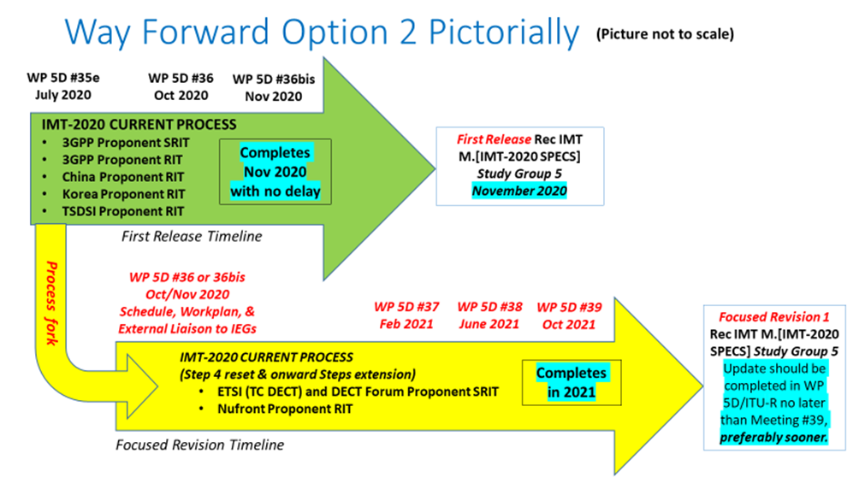
Note: Document IMT-2020/[53] [Editor’s note: Add relevant hyperlink] – Detailed schedule and actions for ‘Way Forward’ Option 2 related to “ETSI (TC DECT) and DECT Forum Proponent” and “NUFRONT Proponent” Candidate Technology Submissions for IMT-2020 provides the detailed schedule and necessary actions for the ‘Way Forward’ Option 2, and should be utilized by ITU-R and the currently engaged relevant External Organizations participating in the existing underway IMT-2020 process for which the ‘Way Forward’ Option 2 is applicable.

ANNEX 2
Materials Useful to the Option 2 Evaluation of the ETSI (TC DECT) and DECT Forum Candidate Technology Submission
As indicated in Document IMT-2020/52 Part 1, the existing completed submissions for these two candidate technologies remain the basis for the evaluations. Additional materials are also available which may facilitate a more in-depth analysis. This includes (not an exhaustive list):
For ETSI (TC DECT) and DECT Forum Proponent:
– The currently “in play” completed Step 3 submissions.
• See - Acknowledgement of submission under Step 3 of the IMT-2020 process in IMT-2020/17(Rev.1)).
– The existing historical record of IEG evaluations relevant to each technology, is still applicable throughout the reset Step 4 –and such evaluations have the opportunity to be re-visited and updated,
• See - Relevant sections of Report ITU-R M.2483-0 – “The outcome of the evaluation, consensus building and decision of the IMT-2020 process (Steps 4 to 7), including characteristics of IMT-2020 radio interfaces”
• Also See - Document 5D/222 Chapter 5, Att. 5.9, ETSI (TC DECT) portions extracted under the way forward (Document IMT-2020/52) for preliminary draft new Report ITU-R M.2483 (5D/TEMP/170) Note: TIES access required. Document available upon request to the Bureau.
– Additionally, taking into account the rich scope of details in the actual specifications previously submitted in anticipation of Step 8
• See - Document 5D/222 Chapter 5, Att. 5.3, ETSI (TC DECT) portions extracted under the way forward (Document IMT-2020/52) for preliminary draft new Recommendation ITU-R M.[IMT-2020.SPECS] (5D/TEMP/173). Note: TIES access required. Document available upon request to the Bureau.
• and further, the CGS materials posted on the WP 5D IMT-2020 Global Core Specifications (and DIS) Note: TIES access required. Document available upon request to the Bureau.
• The new contributions submitted after the original Step 4 had closed as formal contributions to WP 5D Mtg #35e (Documents 5D/156, 157, 158 - Sennheiser Electronic GmbH & Co. KG). Note: TIES access required. Documents available upon request to the Bureau.
– Any newly developed analyses contributed by IEGs and/or members to WP 5D for the reset evaluation Step 4 after WP 5D meeting #35e.
– The Option 2 Proponents and the IEGs as strongly encouraged to utilize the already established ITU-R Evaluation Group discussion area to further the exchange of information in a proactive manner.
ANNEX 3
Materials Useful to the Option 2 Evaluation of the Nufront Candidate Technology Submission
As indicated in Document IMT-2020/52 Part 1, the existing completed submissions for these two candidate technologies remain the basis for the evaluations. Additional materials are also available which may facilitate a more in-depth analysis. This includes (not an exhaustive list):
For Nufront Proponent:
– The currently “in play” completed Step 3 submissions.
• See - Acknowledgement of submission under Step 3 of the IMT-2020 process in IMT-2020/18(Rev.1)).
– The existing historical record of IEG evaluations relevant to each technology, is still applicable throughout the reset Step 4 –and such evaluations have the opportunity to be revisited and updated,
• See - Relevant sections of Report ITU-R M.2483-0 – “The outcome of the evaluation, consensus building and decision of the IMT-2020 process (Steps 4 to 7), including characteristics of IMT-2020 radio interfaces”
• Also See - Document 5D/222 Chapter 5, Att 5.10 , NUFRONT portions extracted under the way forward (Document IMT-2020/52) for preliminary draft new Report ITU-R M.[IMT-2020.OUTCOME] (5D/TEMP/171). Note: TIES access required. Document available upon request to the Bureau.
– Additionally, taking into account the rich scope of details in the actual specifications previously submitted in anticipation of Step 8
• See - Document 5D/222 Chapter 5, Att 5.4, NUFRONT portions extracted under the way forward (document IMT-2020/52) for preliminary draft new Recommendation ITU-R M.[IMT-2020.SPECS] (5D/TEMP/174). Note: TIES access required. Document available upon request to the Bureau.
• and further, the CGS materials posted on the WP 5D IMT-2020 Global Core Specifications (and DIS). Note: TIES access required. Document available upon request to the Bureau.
– Any newly developed analyses contributed by IEGs and/or members to WP 5D for the reset evaluation Step 4 after WP 5D meeting #35e.
– The Option 2 Proponents and the IEGs as strongly encouraged to utilize the already established ITU-R Evaluation Group discussion area to further the exchange of information in a proactive manner.

______________

Registered Evaluation Groups: 5G Infrastructure Association; ATIS WTSC IMT-2020 Evaluation Group; ChEG Chinese Evaluation Group; Canadian Evaluation Group; Wireless World Research Forum; Telecom Centres of Excellence, India; The Fifth Generation Mobile Communications Promotion Forum, Japan; TTA 5G Technology Evaluation Special Project Group; Trans-Pacific Evaluation Group; ETSI Evaluation Group; 5G India Forum; Africa Evaluation Group; Beijing National Research Center for Information Science and Technology (Bnrist EG); Chinese Industry and Research Alliance of Telecommunications (CIRAT).
Anticipated to be provided to the November 2021 meeting of ITU-R Study Group 5.
Note: These contributions to WP 5D are referenced for information only. WP 5D has not made any technical analysis nor acceptance/endorsement of these documents with regard to suitability and/or alignment with the candidate technology submissions and the Step 4 evaluation work previously undertaken, or the evaluation work now initiated under Option 2. These documents only represent the views of the submitting ITU-R member and not those of WP 5D, the Proponent, or any Evaluation Group.

